Woolly Fundraising Ideas
We’ve put together a list of our top creative, fun, and green fundraisers that you can host to raise funds for your Woolly School Garden!

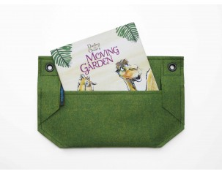
Sell Mini Wallys + Children’s Gardening Book!
Sell the new Mini Wally + Children’s Gardening Book, and 50% of the proceeds will go towards your Woolly School Garden! The Mini Wally + Book is a colorful children's book to inspire parent-child gardening, tucked inside a Mini Wally vertical gardening container, by Woolly Pocket.

Benefit Night at a Local Restaurant!
Partner with a local restaurant, grocery, ice cream/frozen yogurt store to host a benefit night. The restaurant will designate 2-3 hours one evening and a percentage of all purchases made during that time will go directly to your school! Some suggestions: Fresh and Easy, Rubio’s, or Yogurtland.

Host a Farm-raiser!
Connect with your local farm, promote local and healthy foods, and fundraise for your school garden!
See http://departments.oxy.edu/uepi/publications/farmraisers.pdf for details!

Home Harvest
Sell fruit and vegetables from parents’ backyards to raise money for your school garden.

Sell Seeds!
Because every plant starts with a seed.

Renee’s Garden [http://www.reneesgarden.com/fundraiser.html] and Seed Savers [[http://www.seedsavers.org/Content.aspx?src=fundraiser.htm] both have programs to let you sell their seeds, and make a profit! You can also partner with a local nursery to sell plants and seedlings.

Host a Bake Sale!
Bake sales are fun, encourage eating home made goodies, and get the whole community involved!

Host a Crazy Hat/Crazy Hair Day at School
Students pay $1 to wear a crazy hat/hair style to school. You can also have a Free Dress Day (for uniform wearing schools) in which students pay a dollar to wear street clothes for one day!

Think recycle!
Collect bottles & cans, and recycle them for cash! You can help the environment and raise funds for your school garden at the same time.

Host a Movie Night!
All you need is the school gym, a projector, and your favorite movie!

