BY FALL!

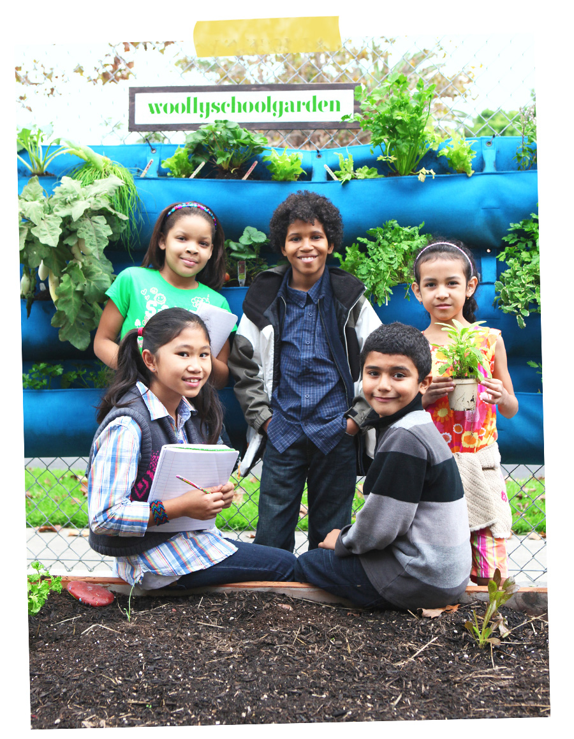

{NAME OF SCHOOL} is joining more than 700 schools across the country participating in the Woolly School Garden program. A Woolly School Garden includes everything our school needs to create an amazing outdoor classroom.

WE NEED YOUR HELP!
In order to start the Woolly School Garden program at our school and begin teaching gardening and nutrition, we need $1000. To donate to our garden go to www.woollyschoolgarden.org, click on SCHOOLS and type in {NAME OF SCHOOL} to be taken to our donation page, where you can donate directly to our garden.

OR, GO DIRECTLY TO:
{insert your full donation link here, which you can find in my email to you! }

The Garden Team at {NAME OF SCHOOL}
Questions? Contact {INSERT YOUR NAME HERE} at {INSERT EMAIL/PHONE HERE}

